**TOEFL SPEAKING**

TASK 1 –

* You’ll be asked a general question about your opinion on a topic.
* Expect familiar topics. You’ll be asked general questions about broad social issues.
* You’ll have a relatively short time to take notes and gather your thoughts.
* Preparation time is 15 seconds and response time is 45 seconds.
* Basic task: **take a position and give specific reasons for your position**.

Look at this TOEFL Speaking Task 1 question:

* *Some people think it is very important to have social interactions with neighbours. Others feel it is not important for neighbours to know each other. Which do you agree with, and why?*

**Keep your statement-of-opinion short and support your opinion with just one or two points**

Your opinion, as stated, should ideally be one sentence long (or possibly two short sentences). In my response, I’ll choose to side in favour of talking to the neighbours. And I’ll state my position as simply as I can:

* I believe that interacting with your neighbours is important because it turns your neighbourhood into a strong, safe community.

To stay in that 45 second time limit, support your Task 1 opinion with just one or two details. And express those supporting details in 4 or 5 sentences. A simple set of supporting details for my opinion above might look like this:

* When neighbours know each other’s needs and struggles, they can help each other. For example, if you know that your neighbour’s car is broken down, you can drive your neighbour to work until the car is fixed. And a neighbourhood where people interact a lot is safer too. When a neighbour is in danger, neighbours who talk are more likely to notice the danger and react to it. If you visit your neighbours regularly, you will notice if they injure themselves and can’t come to the door, or if their kitchen is on fire.

You may have a complete response right here. Or you might not, depending on the pace of your speech. When I read this response out loud to myself, I finished talking in 38 seconds. That’s a little short. To fill out the time, I’ll need to add one more sentence at the end of my answer.

If you still have some time left after stating your opinion and giving some supporting evidence, it’s a good idea to talk briefly about the other side of the issue. Addressing the other side of the issue makes your answer seem thoughtful and truly complete. But remember, keep it simple. The trick here is to acknowledge the other side of the issue without going into a complicated counter-argument.

INTRODUCTION: The introduction should immediately answer the question asked in the task. State clearly what you are going to speak about or what you prefer. This is like the thesis statement in an essay.

BODY: The body is where you provide the reasons, details or examples to explain or support your answer.

CONCLUSION: Your last sentence allows you to conclude in a logical, powerful and convincing way.

**(Q) Describe something that you do to reduce stress. Explain why it is helpful. Include details and examples to support your answer.**

**Introduction**Reading books helps me to relieve stress like nothing else can.

**Body**This is true for several reasons. First, when I read a book, I mentally enter the world of ideas. I can forget my day-to-day worries.

Second, from an emotional angle, reading is a solitary act. It enables me to spend time alone, away from others. This helps me feel more peaceful.

Third, from a physical perspective, reading allows me to stop working and relax my body. At home, I like to read while lying in bed or on the sofa.

**Conclusion**  
The act of reading transports me to another world. That’s why books are good friends and why reading is such an effective way of reducing my level of stress.

**Transcript of an Example MEEM Speaking Task**

Now we’ll look at how MEEM can work in an actual response.

Do you agree or disagree with the following statement? Use details and examples to explain your argument. **It is very important for the government to fund the arts.**

Now, here’s a response, with each part of the MEEM template labelled:

* **M**AIN IDEA**:** Although I don’t think government funding for the arts is bad, I also don’t think it’s as important as other government funds.
* **E**XPLANATIONS AND **E**XAMPLES: Art is enjoyable, and having well-funded arts is wonderful, but not always practical. The first job of the government is to provide public services, and the second job of the government is to help people in need. Art comes after these priorities. For example, the government shouldn’t pay any money to the arts if it can’t maintain good roads and schools, or it lacks the funding to help families out of poverty.
* **M**AIN IDEA, RESTATED: So, for these reasons, I think art funding should never be treated as an important priority. Too many other government projects are more important.

Let’s use this template to answer an example TOEFL Speaking Task 1 question. Here’s the question:

* **Some schools provide children with health education classes. Other schools send health information to parents so that parents can teach their own children about health issues. Which approach do you think is better, and why?**

On this question, I’ll take the side of teaching health education in school. My explanation of my position will focus on the health expertise a trained teacher has. And the alternative to my position is — as stated in the question — parents teaching health to their kids. Here is a **SEA**template, with my answer:

* **SIDE:** I believe that health education should be taught to children in school.
* **EXPLANATION:** Health teachers have special training and expertise in health. A good teacher can tell kids everything they need to know about health. And health teachers will know how to answer any questions that their students have about healthy living. With this information, kids can keep themselves healthy.
* **ALTERNATIVE:** If health education is just done by parents, kids may not get correct, expert health advice. Most parents aren’t health experts, and some parents might not even have the time to give their kids any health tips at all. So, without regular health classes, kids could be misinformed about health, and might make unhealthy choices that are bad for them.

### Question

*Often, people prepare their food at home and bring it to work or school. Buying food on one’s lunch break is also a popular practice. Which lunch break practice is your favourite? Give supporting details and reasons.*

### Sample Response

*“Personally, I prefer to bring my own food to my job or to school. If I buy food while I’m out of the house, I often buy something that is unhealthy. For example, I might buy candy bars from the vending machine, because I feel too busy to go to the cafeteria or a restaurant. But even cafeteria and restaurant food are sometimes not-so-healthy. I can only control how healthy my food is if I bring it myself.*

*Also, I like to have as much time as possible to relax and to eat when I have a break from school or my job. I don’t want to take extra time to find food and wait in line to buy it. That time’s better spent enjoying the food I brought from home, and chatting with colleagues.*

*Although buying food at work or school seems convenient, it has a higher cost. And I don’t just mean money. Getting food at school or work also takes up precious break time too. And it can be bad for your health… Bringing food from home really is better.”*

## Sample TOEFL Speaking Practice Topics for Task 1

1. Some people prefer work that allows them to move around outdoors. Others feel it is more pleasant to work in an office.   
2. **Snakes should never be kept as pets.**

3. Some people feel they perform better when they have to finish by a strict time. Others feel they do better work if they do not have time pressure.

4. **Parents should buy for their children any books that the children choose to read.**

5. **Students should spend more time learning outside of than within classrooms.**

6. In some areas, summer days are longer, so there is more daylight in the evening and early morning, but winter days are shorter. In other areas, summer and winter days are similar lengths throughout the year.

7. **Movies that are longer than three hours should be made shorter by removing less important scenes.**

8. **Parents who do not regularly exercise should start in order to be good role models for their children.**

9. Some people prefer to respond to emails, phone calls, and other messages they receive immediately. Others take more time to respond.

10. **It’s better to reward employees with gifts and job perks, such as gym memberships or English classes, than it is to simply pay more.**

TASK 2 –

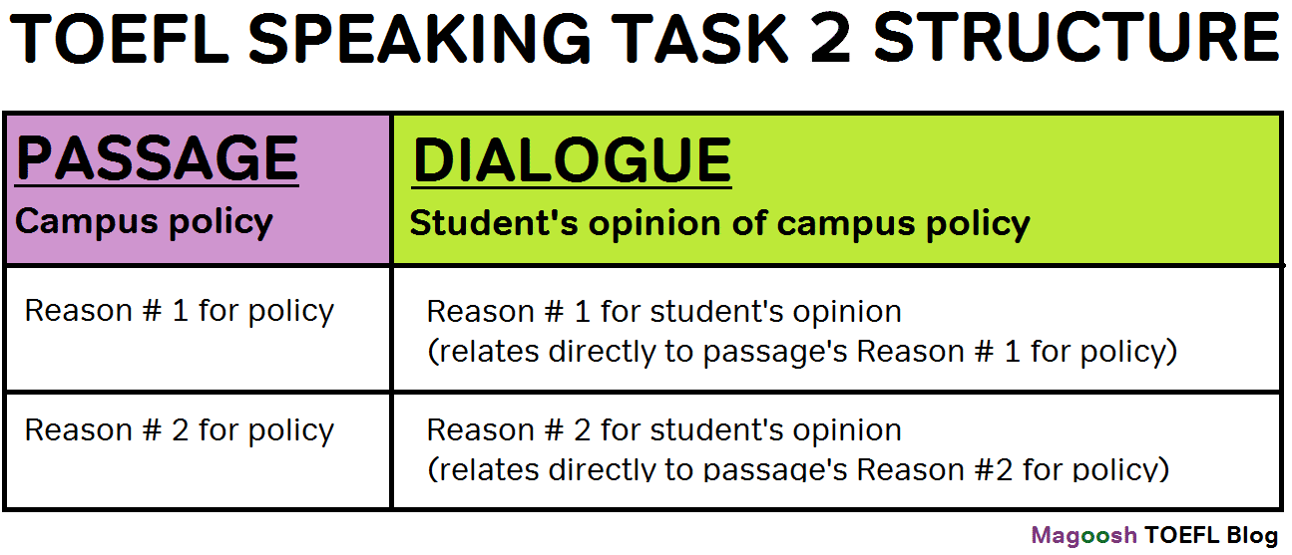

## TOEFL Speaking Task 2 Template Outline

The template works if the student agrees or disagrees with the campus policy. (The student in the Task 2 audio track will always take a clear stance, although they may sometimes partly agree or partly disagree with a supporting detail within the passage.)

Here’s the outline of the template:

1. Summarize passage’s policy, reasons for the policy (speak for about 12 seconds)
2. Say whether the student agrees or disagrees with the policy (speak for about 3 seconds)
3. Summarize student’s response to passage’s reason # 1 for policy (speak for 15-20 seconds)
4. Summarize student’s response to passage’s reason # 2 for the policy (speak for 15-20 seconds)
5. Restate/summarize the student’s main thesis (do this only if there’s time left over).

How to Use this TOEFL Speaking Task 2 Template

This template, with its outline style, is ideal for organizing your notes. If you can boil your Task 2 notes down to just 4 or 5 lines (the 5th line in the template is optional), you should have an easy reference to use for your one-minute speech.

Pay especially close attention to the recommended amount of time in each stage of the template. For most test-takers, it’s very easy to spend too much time summarizing one part of the Task 2 prompt. It’s especially easy to accidentally spend more time than you should on your passage summary. This task really does focus on the conversation and not the passage. So be very time-conscious with step one in this template.

TASK 3 –

TOEFL Speaking Task 3 (the second Integrated Speaking task) is based on a combination of a reading passage and an audio lecture.

It will introduce a topic, often by defining a key term or idea with general descriptions. You can (and should) take notes as you read. Write down the key concept of the passage, and then touch on the main points that the passage makes. You can label these as the first reason, the second reason, and so on. Generally speaking, this information will only be necessary to provide background for your summary of the lecture; lecture-based Integrated Speaking questions do not ask you to discuss the reading passage in detail, because there is much more information in the lecture.

The speaker in the recording for Speaking Task 3 will elaborate on the topic found in the reading passage, by adding more details and giving specific examples that illustrate the information found in the passage. Then you will need to talk in detail about how the lecture explains the ideas described in the text. You will need to use reasons from both prompts to respond.

## Addressing TOEFL Speaking Task 3

A strong response starts with paying attention to the short passage. You must **look for the key academic concept at the beginning of the reading**, and then **look for two supporting details or examples of the concept**. Knowing this before you see the passage allows you to read the passage more quickly and confidently. And in the lecture, you don’t have to worry too much about what information is important in the listening passages. You can know that exactly two pieces of spoken information will be important — two illustrative examples related to the main idea of the passage.

## Speaking Task 3 Sample Response: Revised Version

The passage defines “implicit memory” as an unconscious way to memorize something. In the process, our brain recalls things without any conscious knowledge.

The speaker illustrates this concept with an interesting example. There was a psychological test where a billboard was put on a busy highway. The billboard showed a picture of a brand name car called the Panther. After they drove the highway, commuters were asked if they remembered the billboard ad. Some commuters said they didn’t remember seeing that. But when these commuters were asked to name an animal starting with the letter P, the majority of them said “panther.” This example clearly shows implicit memory at work, because the drivers could remember the panther even if they didn’t consciously remember the billboard.

TASK 4 –

* You’ll listen to a recording of a short lecture by a professor, but this time there will be no accompanying text for you to read.
* You’ll be given 20 seconds of preparation time and 60 seconds of speaking time.
* *Tip:* **Make note of one main point and the two supporting details**.

The professor will usually begin by introducing the topic or a key term, and then will spend the majority of the lecture discussing different interpretations or perspectives on it, the functions of a process, or the causes and effects of a phenomenon. You will be then be asked to summarize the main ideas of the lecture. These questions can be tricky, as they basically require you to re-teach what you just learned. If you try to see the task from this perspective, you will have an easier time answering the question in the way that ETS wants. Give as much detail as you can, and don’t assume that your listener has any knowledge of the topic.

Take good notes during the lecture, summarize what the professor says, prepare for transitions in advance, and avoid putting in your own opinion.